Data Modelling and Form Design

Aim
To design and develop a Gym Membership Application Form using Zoho Creator by creating a structured form, applying appropriate validations, and generating a report for managing member registrations and subscriptions.

Theory
Data modelling and form design involve organizing data into suitable fields and sections for efficient collection and management. In Zoho Creator, forms can be created using different field types such as Name, Email, Address, Phone, Single Line, Multi Line, Number, Date, Time, Drop Down, Radio, Multi Select, and Checkbox.
In this experiment, a Gym_Membership_Form is designed to collect member details, contact information, health and fitness goals, membership tier preferences, and terms & conditions consent. The form is divided into four sections:
- Personal Details: Member Name, Date of Birth, Gender, and ID/PAN Number.
- Contact Details: Email Address, Phone Number, and Residential Address.
- Fitness & Health Profile: Emergency Contact Details, Fitness Goals, and Existing Medical Conditions/Injuries.
- Membership Details & Consent: Membership Plan Type (e.g., Monthly, Quarterly, Annual), Preferred Time Slot, Start Date, and Terms & Rules Consent.

Procedure
- Open Zoho Creator and create the Gym Membership Management application.
- Create the Gym_Membership_Form.
- Add the required fields for personal, contact, health, membership plan, and consent details.
- Organize the fields into the four specified sections (Personal Details, Contact Details, Health & Fitness Profile, and Membership Details & Consent).
- Configure mandatory fields and apply the required validation rules (e.g., minimum age limit, mandatory agreement checkbox).

- Save and preview the form.
- Enter sample member details and submit the form.
- Create the Gym_Membership and verify the submitted records.
- Filter and sort the records based on membership type (e.g., Monthly/Annual) and start date for effective subscription management.

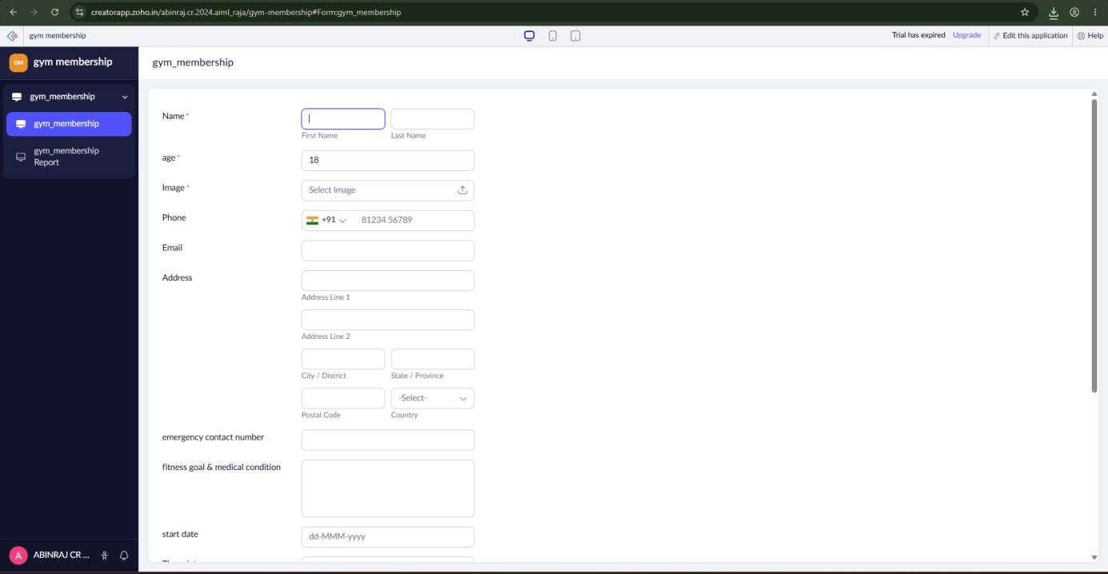
Output

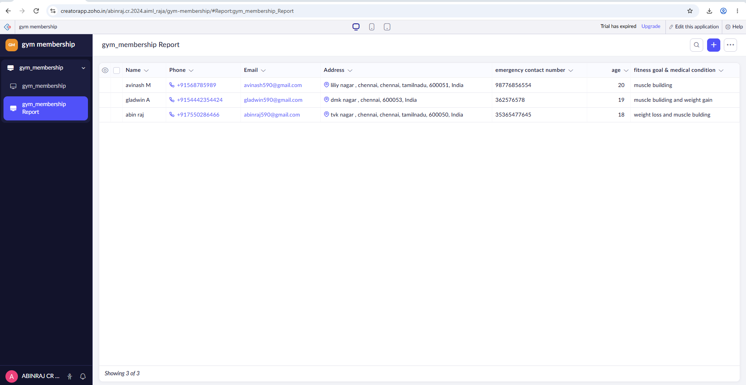
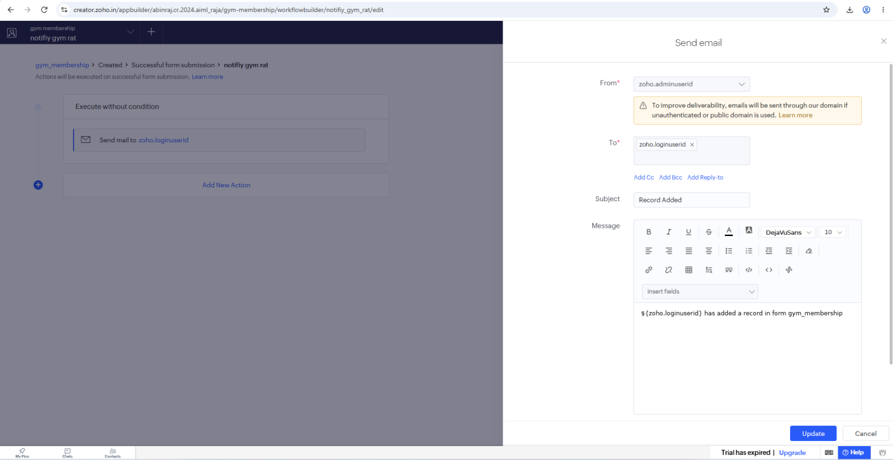

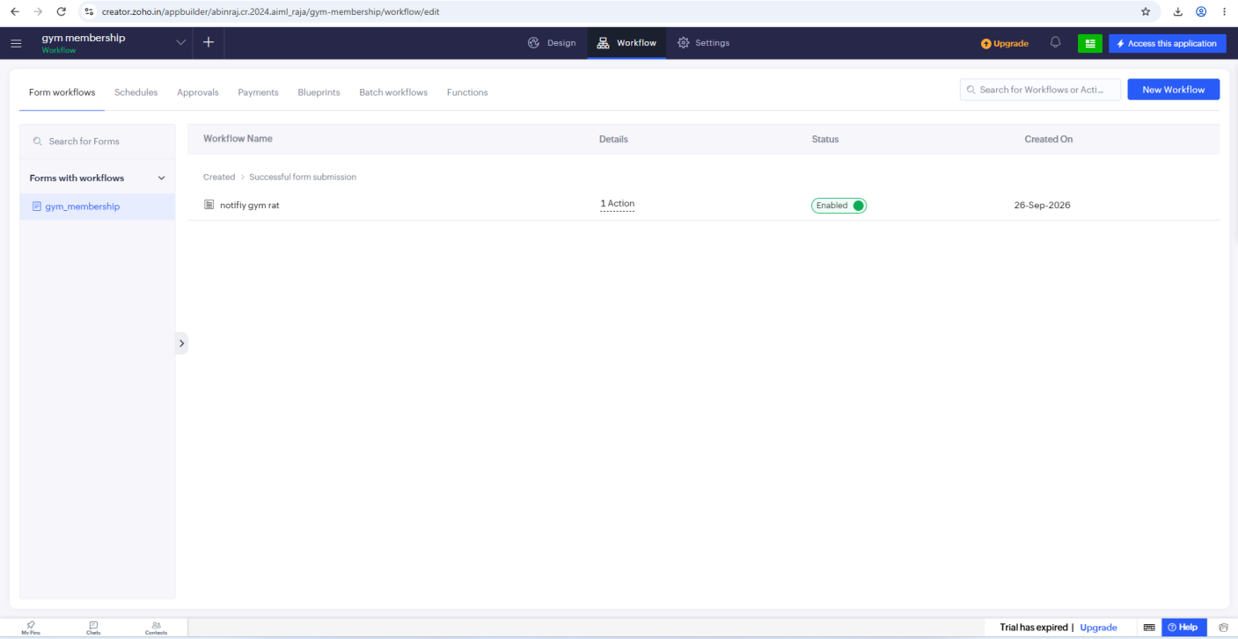

Result
The Gym Membership Application Form was successfully created in Zoho Creator with a structured data model, appropriate field validations, and organized sections. The submitted member applications were successfully stored and displayed in the Gym_Membership for effective onboarding and membership tracking.

